Poem, Paraphrase, and Questions
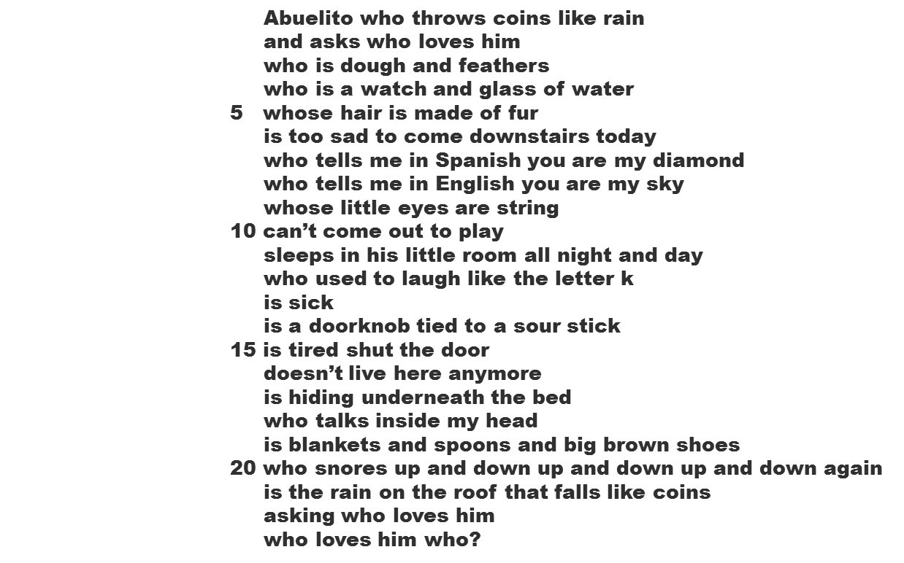
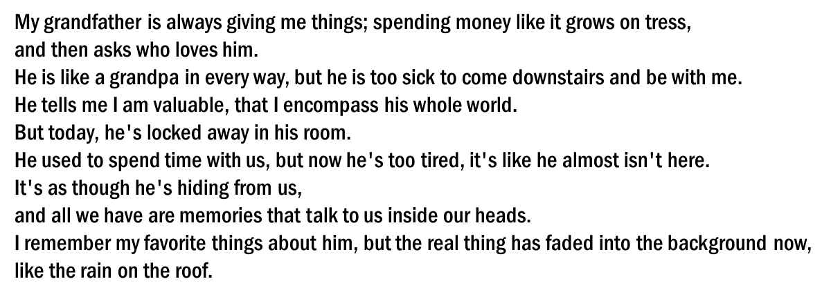
What poetic device does the first line contain?

What image(s) does the author try to create in lines 3, 4, and 5?

What type of figurative language does the author use to describe Abuelito
in lines 14-19?

What imagery does the author use to show the relationship between her
and her Abuelito?

